**Assignment 2**

INFO31179 Human Computer Interaction

Wei Bin Wang

991536233

Professor Ghassem Tofighi

**P1) Procedure of NeedFinding**

**Segment 1**

1. **Who are the end users (audience) of the app you designed prototype for?**
   1. The end users of the app that I designed prototype for are the following groups:
      1. General audience who needs the information about the COVID-19 and its current situations.
      2. For people who would like to know about how to prepare and prevent COVID-19
      3. Seniors who are seeking help when they feel like they have COVID-19
      4. Volunteers who are wiling to help those who are in need due to COVID-19.
2. **What should you consider for each group of audience for your app?**
   1. For people who just want to know about the information regarding current situations and the guidelines to prevent COVID-19, there should be some links that can take them directly to the information they need
   2. For Seniors who are seeking help due to COVID-19, it is important to simplified user interfaces and make the process easier for them.
   3. For Volunteers who would like to help those people in need, they need to be verified and tested to be reliable to
3. **Find similar successful apps to your application, and investigate what users liked or disliked about the application. Mention top five apps almost similar to yours.**
   1. Canada COVID-19, made by Health Canada
      1. Users like this app for its updated data for statistics of current situation, easy to use, facts about the COVID.
      2. Users dislike this app for its lack of details for total cases not including active case number, as well as some minor performance issues.
   2. ABTraceTogether, made by The Government of Alberta
      1. Users like this app for its optimizations to older phones, since a lot of seniors still use older generations of phones.
      2. Users hate this app for inconvenience of tracking, and privacy concern.
   3. COVID-19!, made by Nemocnice Milosrdnych
      1. Users like this app for its details about the statistic including different regions.
      2. Users hate this app for its slow update of the statistic
   4. Coronavirus – COVID19, made by verbaclinc
      1. Users like this app for friendly user interface
      2. Some of the information regarding the statistics are lacking
   5. HEALTHLYNKED COVID-19 Tracker
      1. Users like this app for its functionality, facts about covid-19, and chatting function.
      2. The app suffers with lack of updated data

**Segment 2**

1. **What examples of latent needs can you think of?**
   1. Simplified and clean user interface, this is something that users don’t really know if they really need it. By having easy to access interface, it will great improve user experiences.
   2. Compatibility. Since the COVID app needs to be used by a lot of seniors, who will probably use older phones. its important to make the app that can run as smoothly as possible in those older phones.
2. **What are good ways of finding latent needs?**
   1. Brainstorming – ask a bunch of people test the app and let them share their feedbacks about the app, conduct a review for each feedback
   2. Visualize all the feedback from the volunteers and how they can be translated to the app
   3. Compare competitors’ apps and find out why they do certain things in their apps.

**Segment 3**

1. **List three combinations of user group + activities. Keep the scope appropriate.**
   1. General audience who needs the information about the COVID-19 and its current situations.
      1. Activity: Checking the current statistics of COVID-19
   2. For people who would like to know about how to prepare and prevent COVID-19
      1. Activity: Checking the guidelines or facts about COVID-19
   3. Seniors who are seeking help when they feel like they have COVID-19
      1. Activity: Asking for help due to COVID-19
   4. Volunteers who are wiling to help those who are in need due to COVID-19.
      1. Activity: Checking the list of seniors who are in need due to COVID
2. **Gather data, through desk and field research, about the chosen activity.**
   1. Desk studies
      1. For people who would like to know about the current situation of COVID-19, in terms of statistics, it is important to visit Statistic Canada to get the most accurate results of the data.
      2. For activities like getting help from online chatting, it is important to understand what is the best way for seniors to communicate efficiently, in our case, it is important for those who need help can instantly get help from a public chat room
   2. Field studies
      1. Data about the statistics of COVID-19 need to be carefully examined and observed, they must be obtained from the validated officials
      2. Guidelines also need to be obtained from official Canadian prevention programs
3. **Identify needs/product opportunities**
   1. To track the statistic situations about COVID in Canada as well as provinces like Ontario
   2. Carefully examined symptoms for people who are worried about the potential risk of getting COVID
   3. Provide people with details guidelines and facts about COVID-19
   4. A direct and efficient way for people to use the app to get help when they needed through online chatting with volunteers.

**P1) Procedure of NeedFinding**

**Top five competitors:**

1. Canada COVID-19, made by Health Canada
2. ABTraceTogether, made by The Government of Alberta
3. COVID-19!, made by Nemocnice Milosrdnych
4. Coronavirus – COVID19, made by verbaclinc
5. HEALTHLYNKED COVID-19 Tracker, made by HealthLynked Corp.

**Competitive Analysis**

|  |  |  |  |  |  |  |
| --- | --- | --- | --- | --- | --- | --- |
|  | COVID-19 Assistant  (My app) | Canada COVID-19 | ABTraceTogether | COVID-19!, | Coronavirus – COVID19 | HEALTHLYNKED COVID-19 Tracker |
| Visually pleasing - 8 | no | yes | yes | yes | yes | yes |
| Usability -8 | no | yes | no | yes | yes | yes |
| Easy navigation - 10 | yes | no | yes | yes | no | yes |
| Statistic - 9 | yes | no | no | yes | yes | yes |
| Facts about Covid - 6 | no | no | no | no | yes | no |
| Guidance - 7 | yes | yes | yes | yes | yes | N/A |
| Text Chat - 8 | yes | N/A | N/A | N/A | N/A | yes |
| Total Score | 4.9 | 3.3 | 3.6 | 6 | 5.4 | 6.1 |

**List of UX/HCI issues:**

1. Canada COVID-19, made by Health Canada
   * Lack oh online chat functionality
2. ABTraceTogether, made by The Government of Alberta
   * Lack of statistic information
   * Function not usable when it is closed
3. COVID-19!, made by Nemocnice Milosrdnych
   * User interface looks boring, lack color palette
   * Lack of online chat functionality
4. Coronavirus – COVID19, made by verbaclinc
   * Lack of online chat functionality
   * Statistics are great looking but trying to hard which make it hard to understand in the first glance
5. HEALTHLYNKED COVID-19 Tracker, made by HealthLynked Corp.
   * Lack of guidance of how to prevent COVID
   * Low contrast on icons on the bottom (harder for people with colorblindess)

**List of UX/HCI issues for my app:**

* Login or signup page should only be required for people who needs help when they chat online.
* Dropdown menu is tedious, its better just to use menu on the buttom for each screen, for faster navigation.
* Statistics screen should be segmented for more details, and it is easy to add more features if needed.
* Need to improve contrast for some of the icons.

**P3) Your second prototype using Figma**

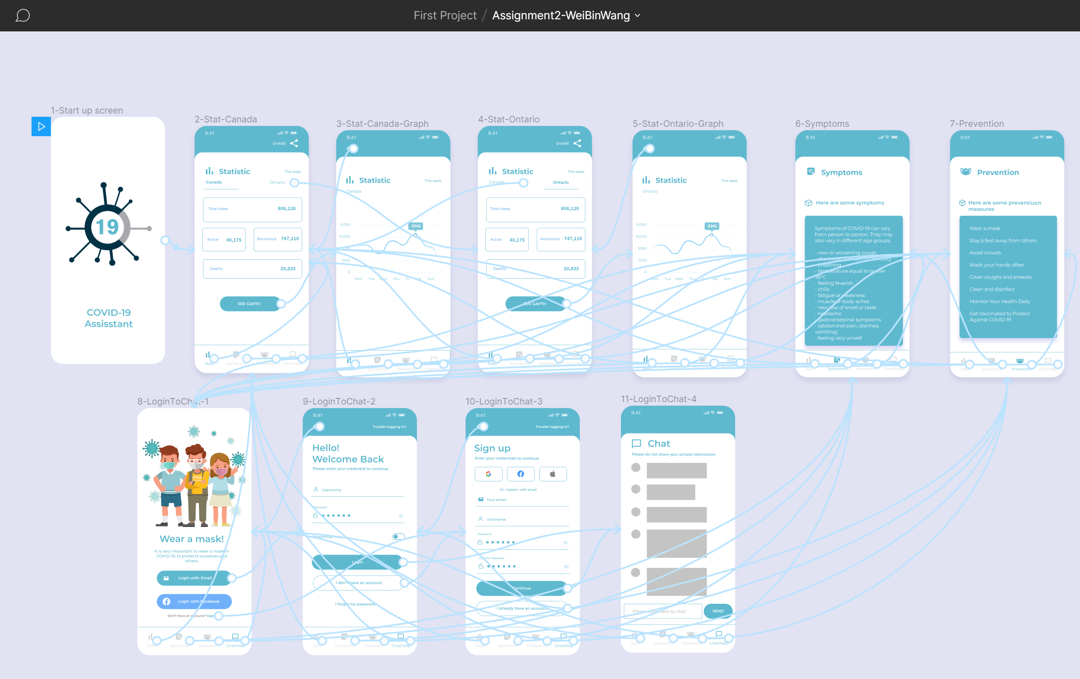

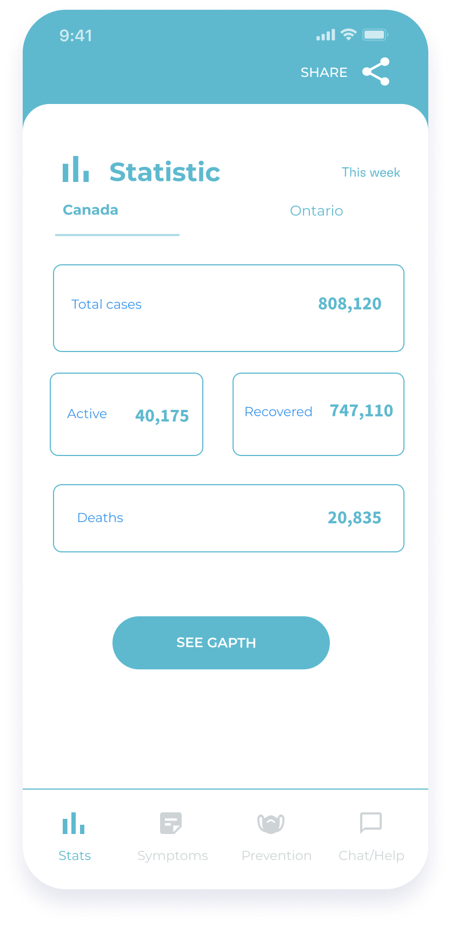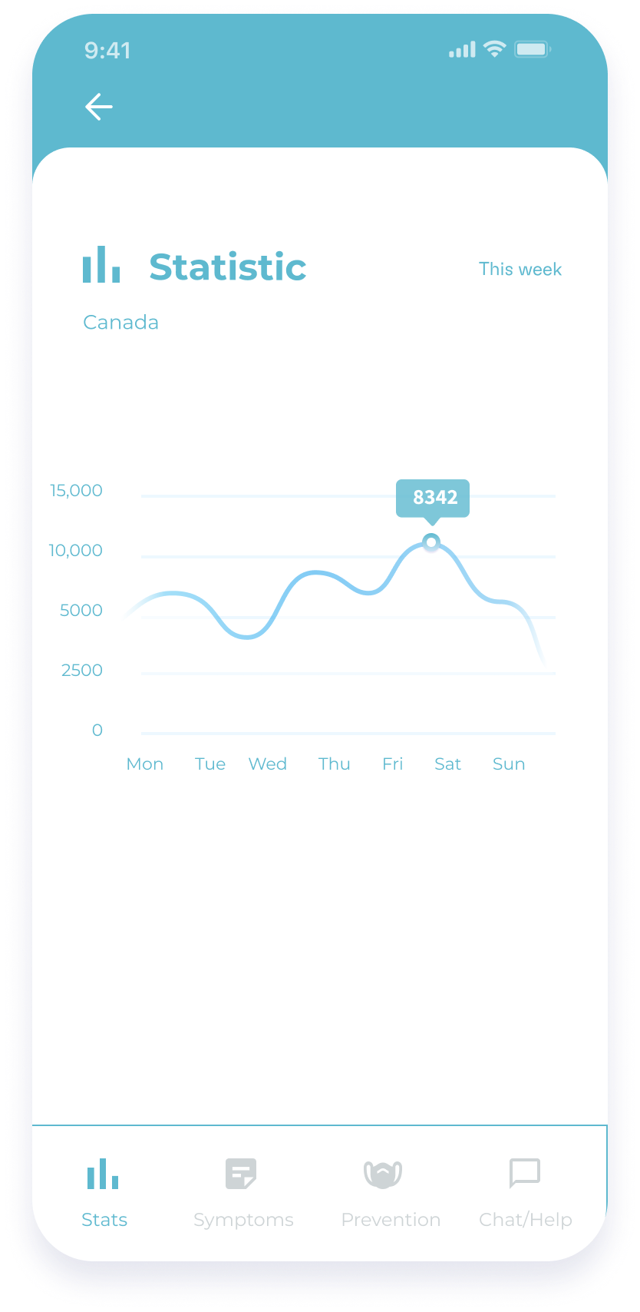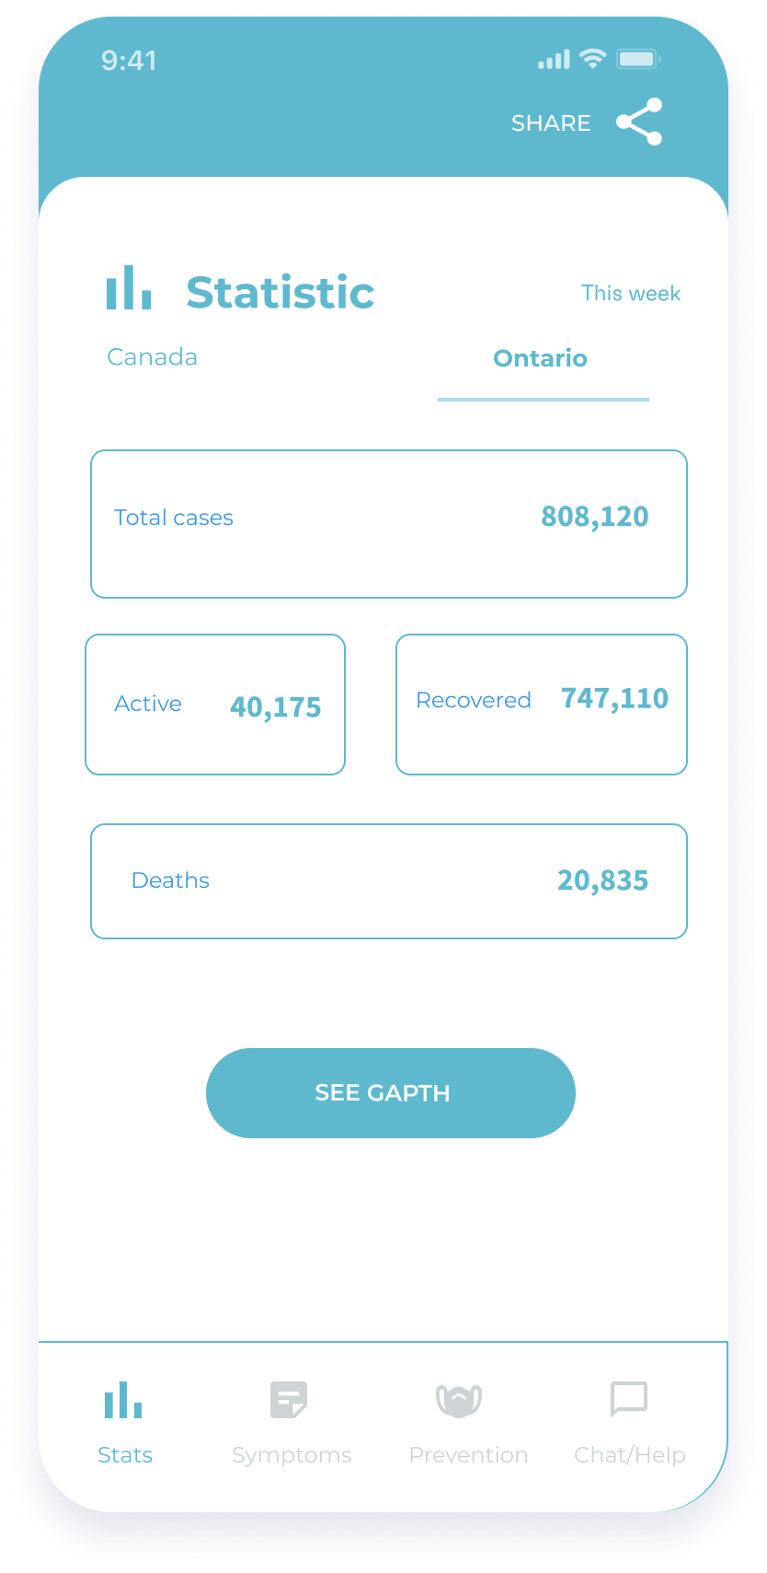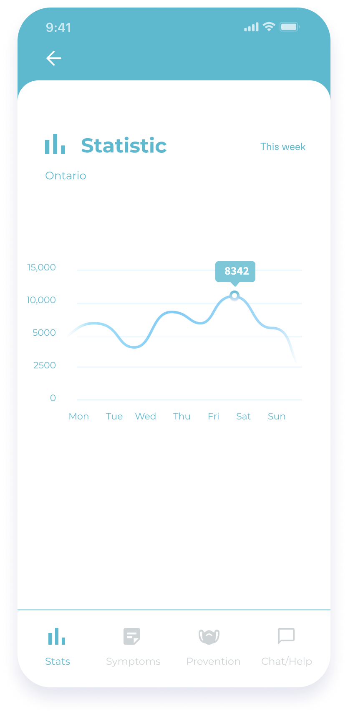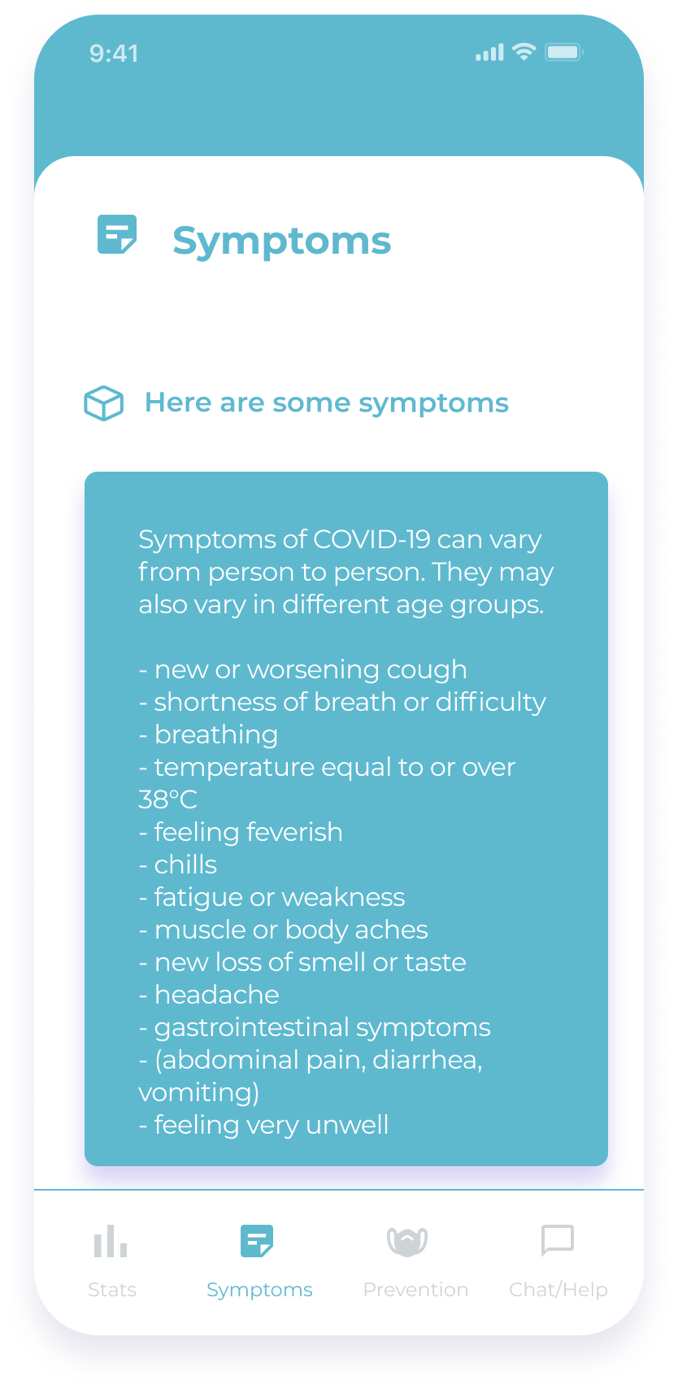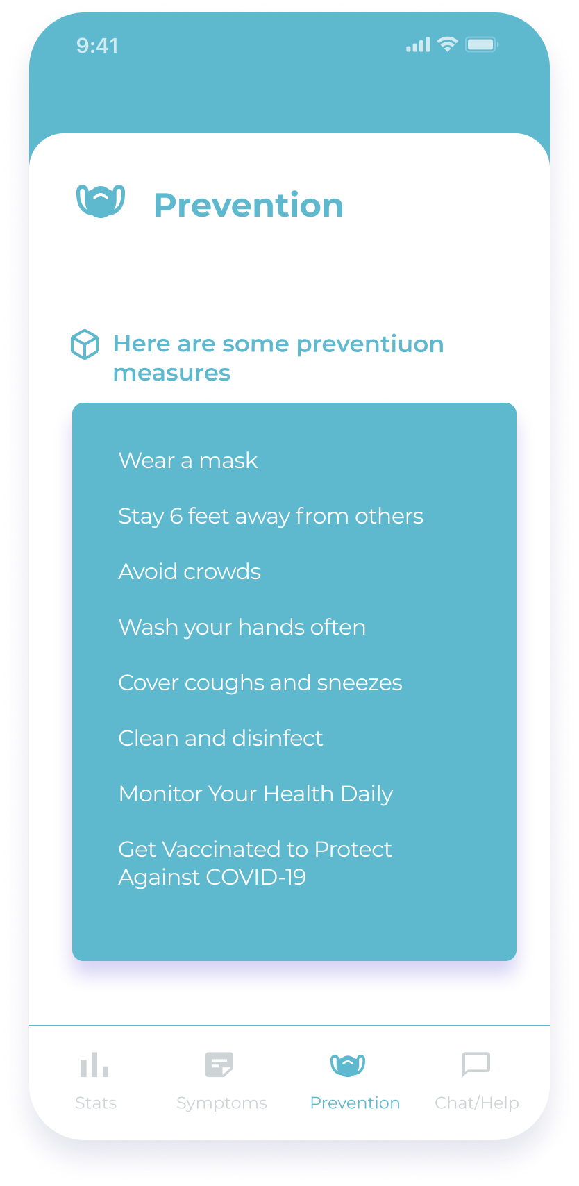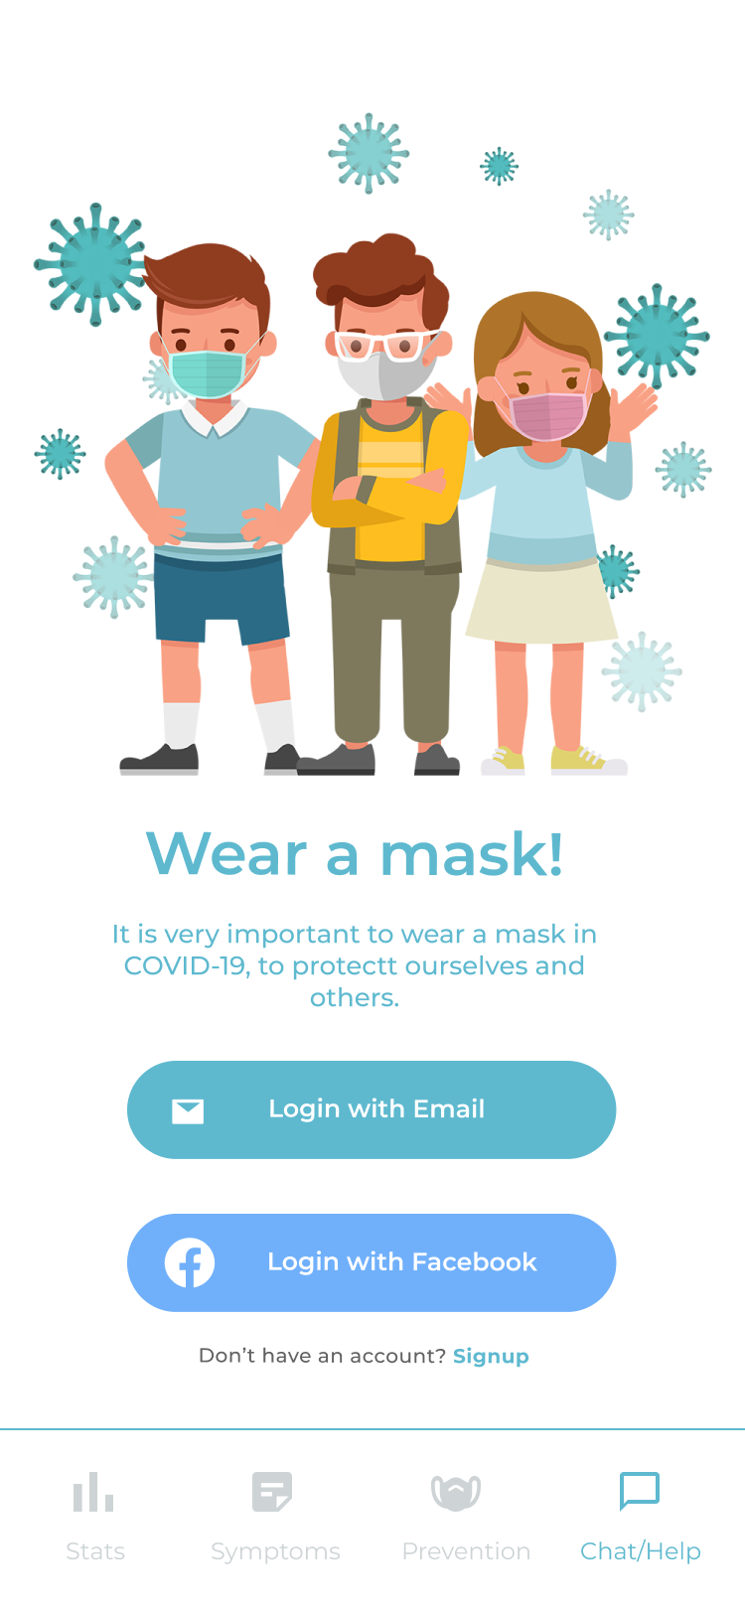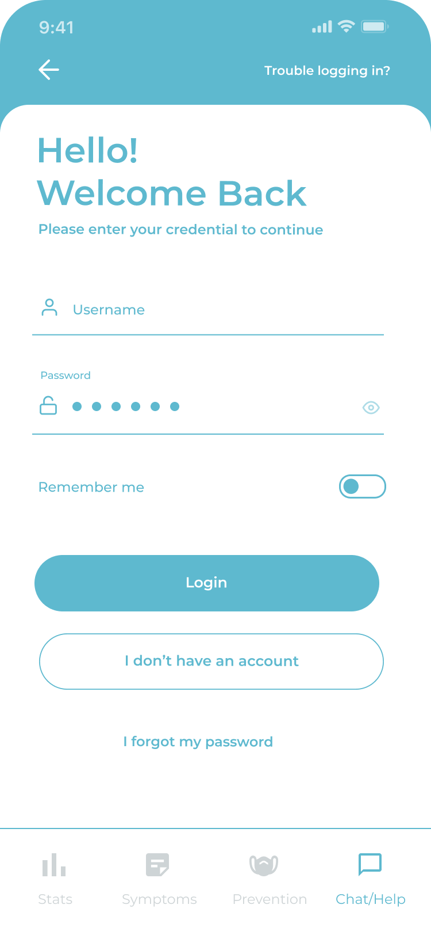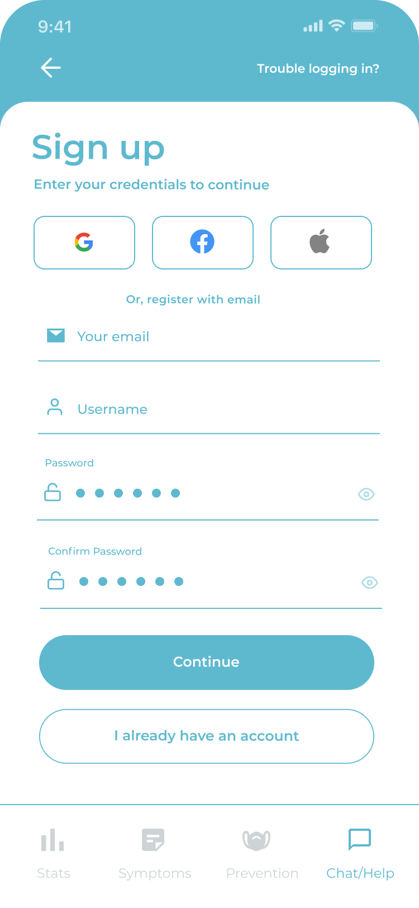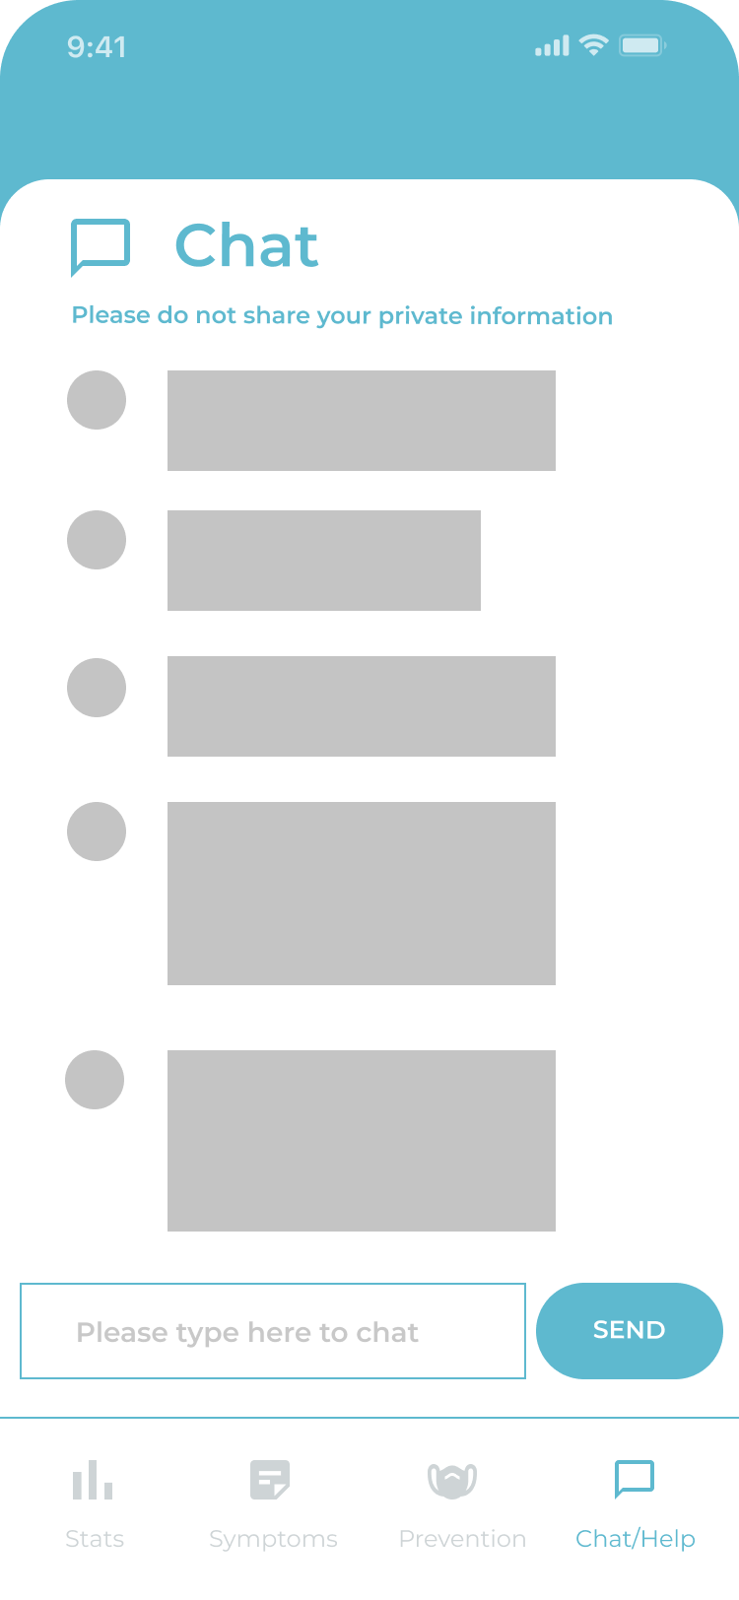

**P4) GitHub and new features**

Github link:

Youtube demo video: